**Linux networking homework**

**For DHCP-server I use Ubuntu server 22.10 with next configure of network interfaces**

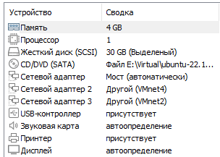

**2 clients have a next configuration**

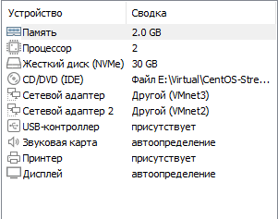

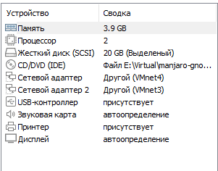

**Task #1 – “**На Server_1 налаштувати статичні адреси на всіх інтерфейсах.”

**I use the SSH connect and “nano” redactor**

**Use command sudo nano /etc/netplan/00-installer-config.yaml**

**and add next lines:**

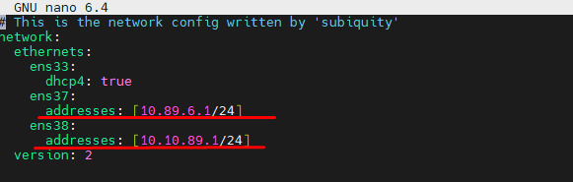

For 2 interfaces which connected to other VM

**Task #2 – “На Server_1 налаштувати DHCP сервіс, який буде конфігурувати адреси Int1 Client_1 та Client_2”**

**For installing DHCP server I use the command**

“sudo apt install isc-dhcp-server”

**After installing I go to configure DHCP for 2 interfaces I use command:**

“sudo nano /etc/dhcp/dhcpd.conf” **and add few lines:**

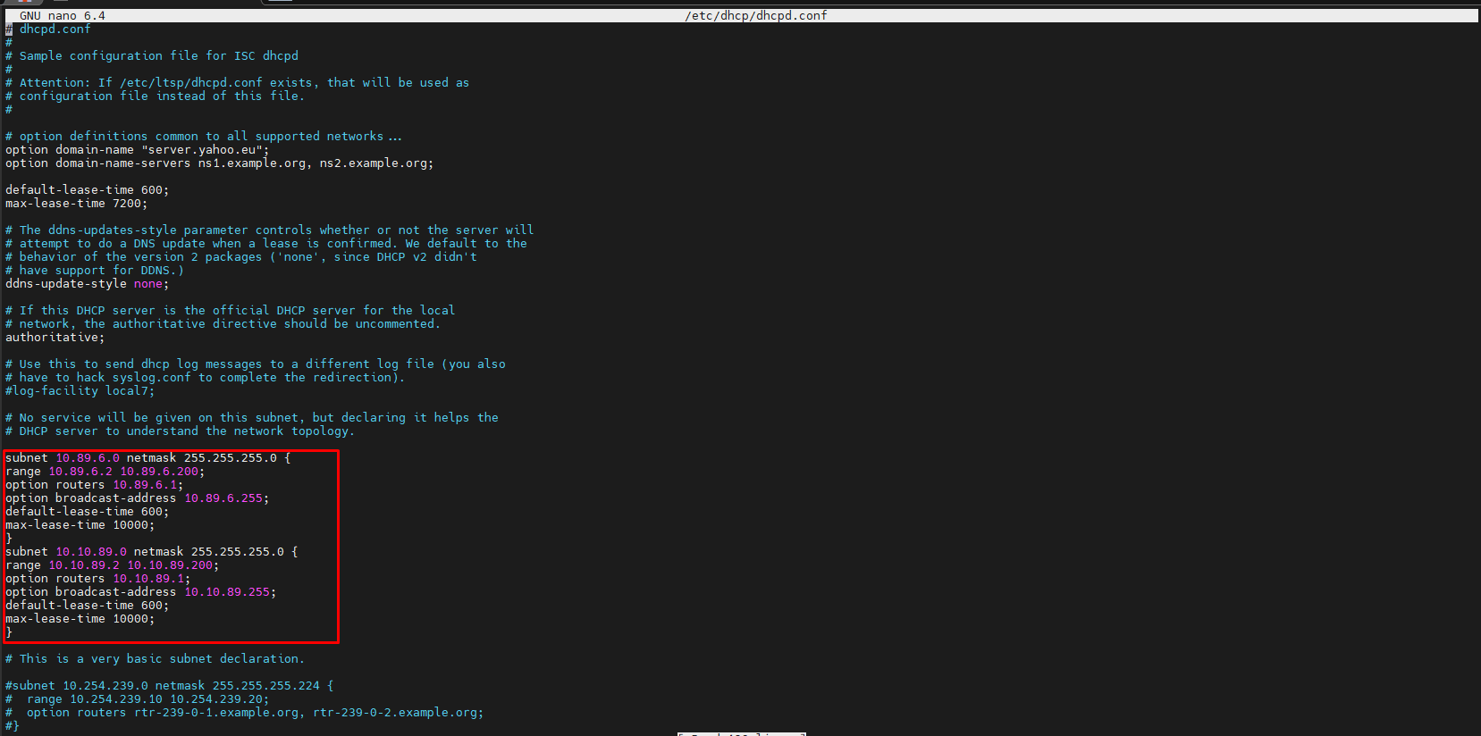

**Then I edit** /etc/default/isc-dhcp-server **file**

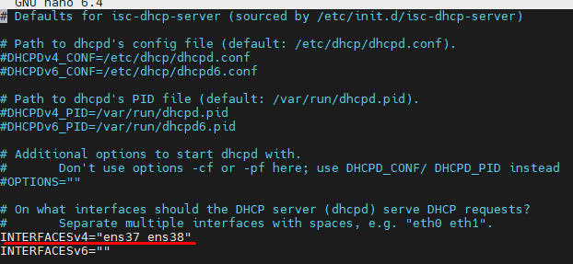

*ens37, ens38 -2 interfaces which I use to contact with Client1 and Client2

**Then on Client1 and Client2 need to add DNS server to get access to internet, so using UI or tervinal get setup DNS for interfaces which connect to Server (I use UI for setup)**

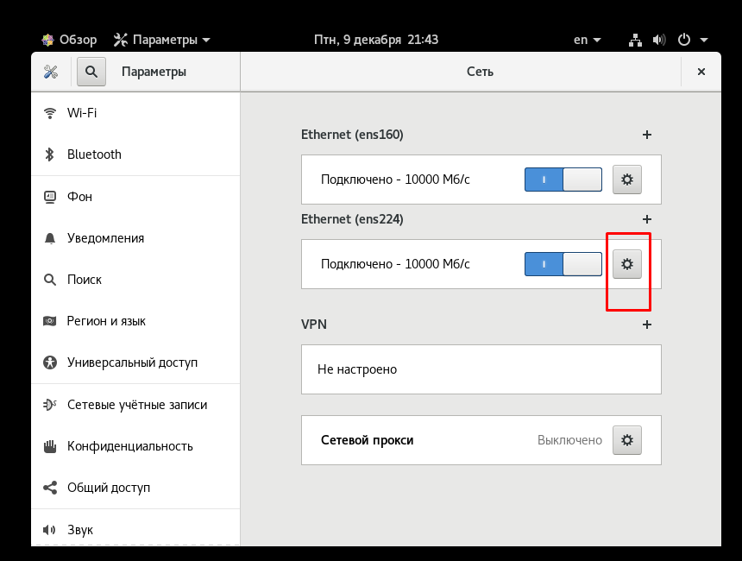

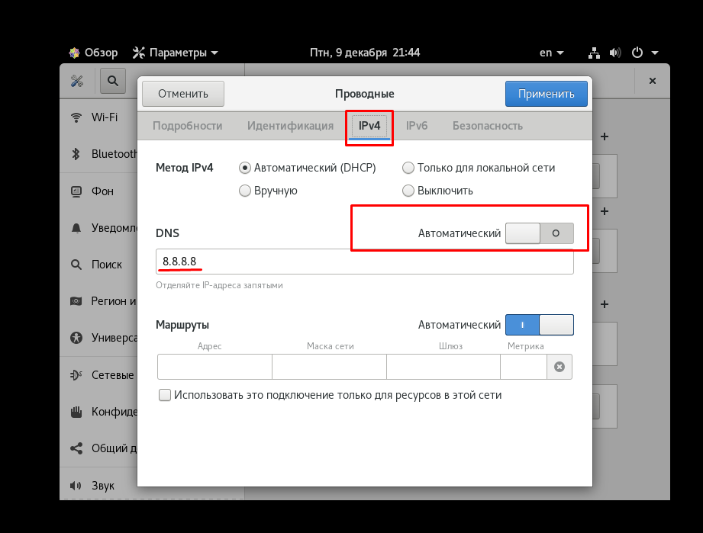

**Take tab IPv4 and off the automatic DNS. After that use 8.8.8.8 IP to have DNS resolve. After that goto server and make permission on iptables/nftables to redirect traffic from the interface to internet with next commands:**

“sudo iptables -t nat -A POSTROUTING -o <Host_Interface_Name> (enp33 my example) -j MASQUERADE”

“sudo iptables -A FORWARD -i <interface_name>(enp37 /enp38 as example) -j ACCEPT”

**Next step, we must save the permissions on iptables:**

**“**sudo iptables-save > <path to> file.conf**”**